ProspectML: Predicting MLB Hitting Ability from Minor League Performance
Nick Codianni
Professor Schirmacher
MA 421
8/17/2026

Executive Summary
This study investigates whether Minor League hitting performance can be used to estimate future offensive performance at the Major League Baseball (MLB) level. The project, called ProspectML, was developed as a statistical framework for evaluating MLB prospects using historical Minor League performance.
To accomplish this, Minor League and MLB hitting data were collected and combined across multiple seasons. The Minor League data were cleaned, standardized, and aggregated into player-level statistics, including career performance and performance at High-A, AA, and AAA. MLB performance was then used to create four target variables: On-Base Percentage (OBP), Isolated Power (ISO), Weighted On-Base Average (wOBA), and Weighted Runs Created Plus (wRC+).
Separate machine learning models were developed to predict each MLB offensive component. These predictions were then combined into a weighted Hitter Ability Score (HAS), which served as the overall measure of MLB offensive ability. A Extra Trees model was selected as the final prediction model after comparing and tuning multiple approaches.
The final ProspectML model achieved an R² of approximately 0.40, with a Mean Absolute Error (MAE) of approximately 0.57 and a Root Mean Squared Error (RMSE) of approximately 0.72. Compared with a baseline model, ProspectML reduced MAE by approximately 26% and RMSE by approximately 23%, demonstrating that Minor League statistics contain meaningful information about future MLB hitting performance.
Several important findings came from the analysis. MLB ISO was the most predictable of the four offensive components, with an R² of approximately 0.58. Career Minor League statistics were by far the most important information source in the final model, accounting for approximately 71.7% of average feature importance. AAA statistics contributed approximately 12.9%, followed by AA at 8.2% and High-A at 7.3%.
The model also demonstrated an important limitation. ProspectML struggled to predict extreme outcomes, particularly future superstar-level performance. Players with an absolute actual HAS of at least 2 had an average absolute prediction error of approximately 1.39, compared with an overall average absolute error of approximately 0.46. This indicates that the model tends to pull extreme outcomes toward the center of the distribution.
Overall, the results suggest that Minor League statistics can provide a useful statistical baseline for prospect evaluation, but they cannot completely explain future MLB performance. ProspectML should therefore be viewed as a decision-support tool rather than a replacement for scouting or a definitive prospect ranking system. Future versions could improve the model by incorporating player-tracking data, scouting information, competition adjustments, player development trends, and players who did not ultimately reach MLB.

Project Goal
The purpose of this project is to determine how effectively Minor League hitting statistics can be used to estimate future MLB offensive performance.
Specifically, the analysis was designed to answer five major questions:
- Which MLB offensive skills are most predictable from Minor League performance?
- Which Minor League statistics are most important to predicting MLB performance?
- Does the level at which a player performs affect the predictive value of their statistics?
- Where does ProspectML succeed and fail?
- What can ProspectML realistically be used for?
This type of analysis reflects a real-world challenge in baseball analytics. MLB organizations must evaluate players before knowing how their skills will translate against Major League competition. Minor League statistics provide measurable information about a player's performance, but the relationship between Minor League success and MLB success is not perfect.
The goal of ProspectML was therefore not simply to create the most accurate possible prediction, but to investigate what information is transferable from the Minor Leagues to MLB and where uncertainty remains, however further improvements to the model could make it a more useful tool for evaluating prospects.

Data Sources and Preparation
This project combines historical Minor League and MLB hitting data. The primary performance data were collected from FanGraphs and organized into player-level datasets covering multiple seasons.
The Minor League data included statistics from High-A, AA, and AAA, as well as career-level statistics. Variables included batting average, on-base percentage, slugging percentage, isolated power, walk rate, strikeout rate, BB/K, wOBA, wRC+, and other offensive statistics.
The MLB dataset contained the corresponding MLB outcomes needed to evaluate how well Minor League performance translated to the Major League level.
Because the datasets used different player identifiers and naming conventions, substantial data cleaning was required. Player names were standardized by converting names to a consistent format and removing accents and punctuation. A player ID system was also created to improve consistency when merging datasets.
The Minor League data were then combined into player-level records. Career statistics and level-specific statistics were calculated so that each player could be evaluated using both their overall Minor League performance and their performance at individual levels.
A plate appearance cutoff was used to remove players with extremely limited statistical samples. The final modeling dataset contained 936 players.
The final model used 33 features. These included Minor League offensive statistics, career statistics, level-specific statistics, and age-related variables.
The overall data workflow can be summarized as:
Minor League Data → Cleaning and Standardization → Player-Level Aggregation → MLB Outcomes → Feature Engineering → Component Models → Hitter Ability Score → Final Extra Treer
This process allowed the project to move from raw historical baseball statistics to a player-level predictive framework.

Methodology
MLB Offensive Targets
Rather than attempting to predict a single MLB statistic directly, the project separated offensive performance into four components:
- MLB OBP
- MLB ISO
- MLB wOBA
- MLB wRC+
This approach allowed the project to determine which aspects of hitting were more predictable than others.
Each component was modeled separately using Minor League statistics.

Hitter Ability Score
The four MLB component predictions were combined into a single Hitter Ability Score.
The weighting was:
- OBP: 15%
- ISO: 15%
- wOBA: 35%
- wRC+: 35%
The purpose of this weighting was to prevent the final score from being dominated by power simply because ISO happened to be easier to predict. wOBA and wRC+ were given greater weight because they provide broader measures of offensive production.
The four component statistics were standardized before being combined so that statistics measured on different scales could contribute to the same overall score.
HAS therefore represents a constructed measure of overall offensive ability rather than an official MLB statistic.

Feature Selection
Before finalizing the model, correlations between Minor League statistics and MLB outcomes were examined to identify which variables contained useful predictive information.
This analysis showed that many of the strongest relationships involved career statistics. Career OBP, ISO, wOBA, OPS, SLG, and wRC+ repeatedly appeared among the strongest predictors.
Feature importance from the Extra Trees model was then used to determine which variables contributed the most to the final predictions.
Features with consistently low importance were removed during the model-reduction process. The final model contained 33 features.

Model Selection and Tuning
Several machine learning approaches were considered during the project. Extra Trees ultimately provided the strongest overall performance and was selected as the final model.
The Extra Trees model was then tuned by testing different combinations of:
- Number of trees
- Maximum tree depth
- Minimum samples per split
- Minimum samples per leaf
- Number of features considered at each split
- Bootstrap sampling
The final model was evaluated using three primary metrics:
Mean Absolute Error (MAE) measures the average size of the prediction error.
Root Mean Squared Error (RMSE) gives greater weight to larger errors.
R² measures the proportion of variation in the target explained by the model.

Findings
1. Power Is the Most Predictable MLB Offensive Skill
The first question was which MLB offensive components could be predicted most effectively from Minor League performance.
The final component models produced the following results:
Target | MAE | RMSE | R²
MLB OBP | 0.0166 | 0.0208 | 0.3396
MLB ISO | 0.0227 | 0.0285 | 0.5753
MLB wOBA | 0.0172 | 0.0215 | 0.3673
MLB wRC+ | 11.6043 | 14.5660 | 0.3971
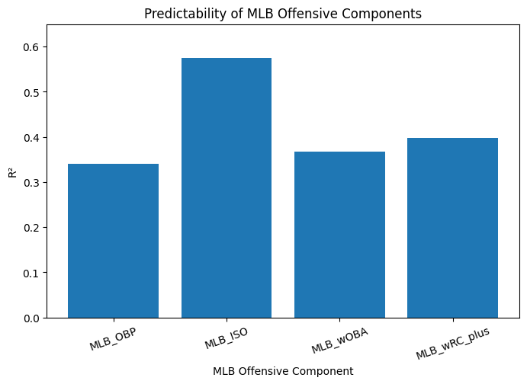
MLB ISO had the strongest predictive performance, with an R² of approximately 0.58. This was substantially higher than the R² values for OBP, wOBA, and wRC+.
This suggests that power is one of the more transferable aspects of Minor League hitting performance. ISO is based primarily on extra-base hit production and therefore captures a relatively specific offensive skill.
In contrast, metrics such as wRC+ incorporate more contextual and league-adjusted information, making their translation from Minor League to MLB more complicated.
The results do not mean that power is the only important offensive skill. Instead, they indicate that power was the easiest component for the model to predict consistently.
This finding also influenced the construction of HAS. Although ISO was easier to predict, it was not given a disproportionately large weight in the final score because doing so would cause the overall ranking to favor power hitters simply because power was statistically easier to project.

2. Career Minor League Performance Dominates the Model
The second question was which types of Minor League statistics contributed the most to the final model.
The average feature importance by group was:
Group | Average Importance
Career | 0.7169
AAA | 0.1287
AA | 0.0816
High-A | 0.0728
Level Experience | 0.0000
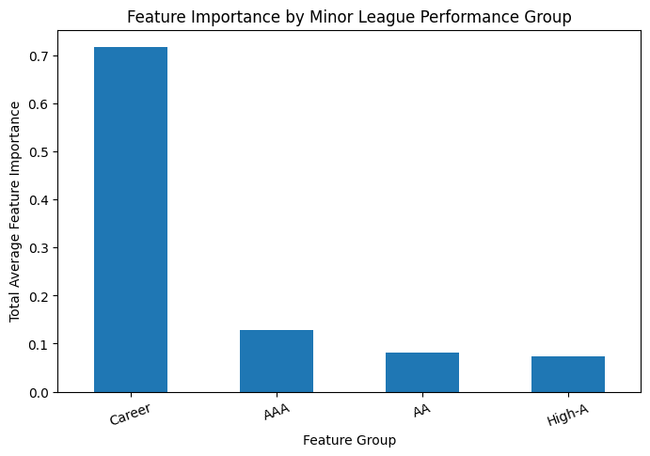
Career statistics were clearly the most important group of variables, accounting for approximately 71.7% of average feature importance.
The most important individual features included:
Feature | Average Importance
Career_wRC_plus | 0.1679
Career_ISO | 0.1045
Career_wOBA | 0.0931
Career_OPS | 0.0769
Career_OBP | 0.0751
Career_SLG | 0.0663
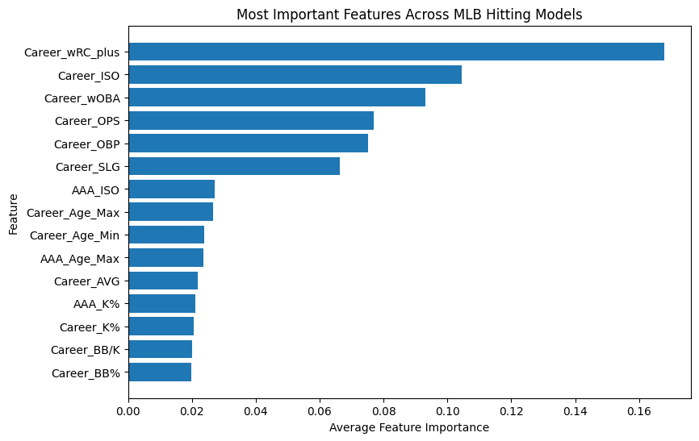
The dominance of career statistics suggests that a player's overall Minor League track record contains considerably more information than performance from a single level.
This result makes intuitive sense. Career statistics contain more plate appearances and therefore provide a larger sample of a player's ability. They also reduce the impact of unusually good or bad individual seasons.
However, the dominance of career statistics should also be interpreted carefully. Career statistics naturally contain more observations than individual-level statistics, so part of their advantage may come from just simply having a larger sample size.

3. Higher Minor League Levels Provide More Information
The third question examined whether the level at which a player performed affected the predictive value of their statistics.
The final dataset contained:
Level | Players With Experience
High-A | 810
AA | 854
AAA | 892
AAA statistics had the highest average feature importance among the individual Minor League levels:
- AAA: 0.1287
- AA: 0.0816
- High-A: 0.0728
The average absolute correlations between level-specific statistics and the four MLB outcomes were:
- AAA: 0.1376
- AA: 0.1356
- High-A: 0.1064
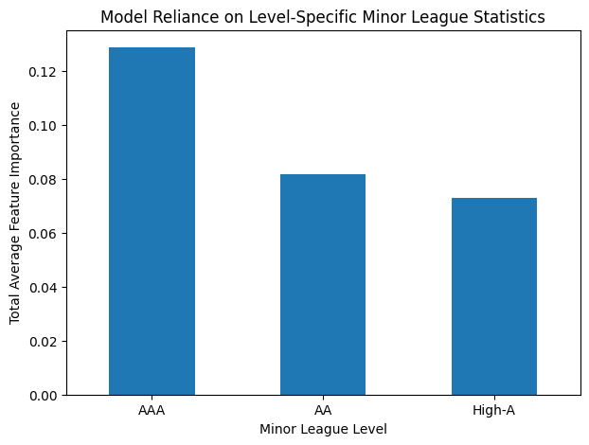
These results suggest that higher-level Minor League performance provides more information about future MLB hitting than High-A performance.
However, the difference between AAA and AA was very small. Therefore, the results do not support the conclusion that AAA is dramatically more predictive than AA.
The strongest individual level-specific relationship was between AA ISO and MLB ISO, which had a correlation of approximately 0.433.
This is another indication that power is relatively transferable across levels.
The results also need to be interpreted with the structure of the dataset in mind. The number of players with experience at each level was not identical, and the dataset consists of players who eventually reached the MLB sample. Therefore, level-specific results should not be interpreted as universal statements about every Minor League player. This question can be further examined in the future by adding players to the dataset that never reached the MLB.
Overall, the evidence suggests that level of competition matters, but a player's broader career performance remains substantially more informative than performance at any single level.

4. ProspectML Struggles With Extreme Outcomes
The fourth question examined where the model performs poorly.
The largest underpredictions were concentrated among several of the most successful MLB hitters in the dataset.
For example:
Player | Actual HAS | Predicted HAS | Error
Aaron Judge | 4.336 | 1.279 | -3.057
Mike Trout | 3.720 | 1.697 | -2.023
Ronald Acuña Jr. | 2.712 | 0.750 | -1.962
Yordan Alvarez | 3.460 | 1.702 | -1.758
Freddie Freeman | 2.540 | 0.953 | -1.586
Joey Votto | 2.939 | 1.370 | -1.568
The model also produced large overpredictions for players who ultimately produced relatively poor MLB offensive outcomes.
For example, Isan Díaz had an actual HAS of -2.159 but a predicted HAS of approximately -0.031, resulting in the largest positive prediction error of 2.128.
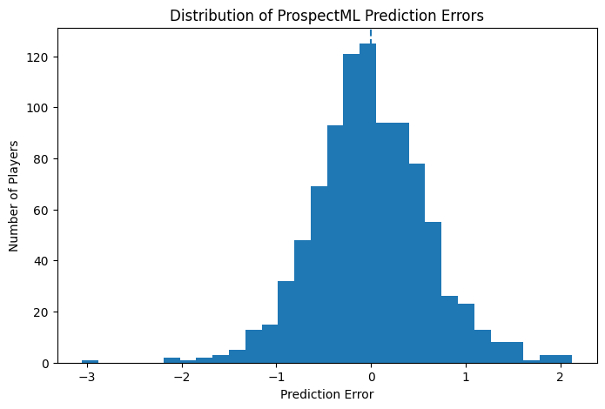
The overall range of actual and predicted HAS also demonstrates this limitation.
Actual HAS ranged from approximately -2.81 to 4.34, while predicted HAS ranged from approximately -1.44 to 1.76.
The average absolute actual HAS was approximately 0.735, compared with an average absolute predicted HAS of approximately 0.463.
This indicates that the model's predictions were considerably more concentrated around the center of the distribution than the actual outcomes.
The difference becomes even clearer when looking specifically at extreme players. There were 32 players with an absolute actual HAS of at least 2.
For these players:
- Average absolute prediction error = 1.391
- Overall average absolute prediction error = 0.464
Therefore, extreme outcomes produced approximately three times the typical prediction error.
This suggests that ProspectML is more effective at estimating a player's general offensive ability than identifying extreme outcomes.
In particular, the model has difficulty identifying players who will become exceptional MLB hitters. Aaron Judge and Mike Trout are useful examples because their eventual MLB performance substantially exceeded what the available Minor League statistics suggested.
This limitation is important because some of the most valuable outcomes in prospect evaluation are precisely the players who substantially outperform expectations.

5. What Can ProspectML Actually Tell Us?
The final question was not simply whether the model was accurate, but what the model can realistically be used for.
The finalized ProspectML model produced:
- MAE: 0.5719
- RMSE: 0.7186
- R²: 0.4027
The baseline model produced:
- MAE: 0.7743
- RMSE: 0.9348
- R²: -0.0107
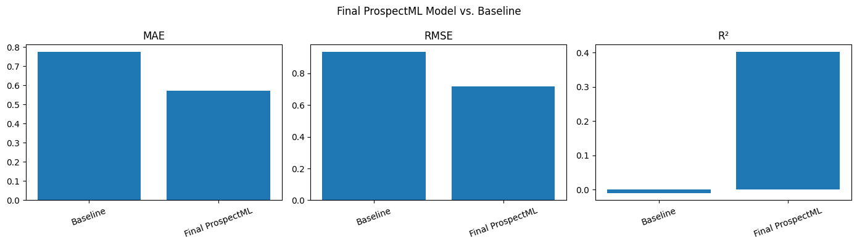
Compared with the baseline, ProspectML reduced MAE by approximately 26% and RMSE by approximately 23%.
The baseline's R² was approximately zero, meaning that simply predicting the average outcome provided essentially no useful predictive improvement. ProspectML's R² of approximately 0.40 demonstrates that the Minor League statistics contain meaningful predictive information.
Therefore, ProspectML can provide several useful functions in a baseball analytics environment.
First, it can establish a statistical baseline for a prospect. Instead of evaluating a player without context, analysts can compare the player's Minor League profile to the profiles of historical players.
Second, ProspectML can help identify strong or unusual offensive profiles. A player who receives a strong projection can be flagged for additional scouting and evaluation.
Third, the model can help analysts understand which skills appear to transfer to MLB. The results from this project suggest that power and established career production are particularly useful signals.
Finally, the model can help generate questions rather than simply provide answers. A prospect who receives a surprisingly low or high projection may warrant additional investigation into information that is not captured by the model.
Important Considerations
Several limitations should be considered when interpreting the results of this project.
HAS Is a Constructed Metric
Hitter Ability Score is not an official MLB statistic. It was created specifically for this project by combining four MLB offensive outcomes.
Therefore, HAS should be interpreted as a summary measure of offensive performance within this project rather than as a definitive measure of player value.
The Dataset Contains Players Who Reached MLB
The dataset consists of players who met the MLB inclusion criteria. Players who never reached MLB are not represented in the final modeling sample.
This creates an important selection bias. The model is therefore primarily answering:
Among players who reached MLB, how well can their eventual offensive ability be estimated from their Minor League performance?
It is not yet answering:
Which Minor League players are most likely to reach MLB?
Including players who did not reach MLB would allow future versions of ProspectML to address that second question.
Career Statistics Have an Information Advantage
Career statistics were substantially more important than individual-level statistics. This may partly reflect their larger number of plate appearances and greater statistical stability.
Therefore, the dominance of career statistics should not automatically be interpreted as proof that career statistics are inherently more predictive than every other type of information.
Power May Be Easier to Predict
ISO was considerably easier to predict than OBP, wOBA, and wRC+.
This may be partly because power is a relatively stable offensive characteristic and is less dependent on certain contextual adjustments than some other metrics.
Prediction Error Is Not Uniform
The model does not perform equally well for every player.
Extreme outcomes produced substantially larger errors than typical players. Therefore, an individual ProspectML prediction should not be treated as equally reliable across the entire range of possible outcomes.
Model Predictions Are Not Scouting Grades
A ProspectML score represents what the historical statistical model expects based on the available data. It does not measure work ethic, makeup, mechanical changes, injuries, defensive ability, physical development, or other factors that scouts and player-development staff may consider.

Future Improvements
Although ProspectML provides meaningful predictive information, several improvements could make the model more accurate and more useful in a real baseball environment.
1. Add Player-Tracking Data
The current model relies primarily on traditional statistics. Future versions could incorporate tracking data such as:
- Exit velocity
- Hard-hit rate
- Barrel rate
- Launch angle
- Bat speed
- Contact quality
- Chase rate
- Contact rate
These variables could provide information about the underlying quality of a player's performance rather than simply the results.
2. Better Account for Level of Competition
The current model includes High-A, AA, and AAA statistics, but does not fully adjust for differences in competition.
A future version could incorporate league- and level-adjusted statistics to better compare similar performances across different levels.
This would help distinguish between a player producing strong numbers against weaker competition and a player producing similar numbers against more advanced competition.
3. Incorporate Player Development Trends
The finalized model relies heavily on career statistics. While this provides stability, it can also hide recent changes in a player's development.
Future models could incorporate:
- Year-to-year changes in wRC+
- Changes in ISO
- Changes in BB% and K%
- Recent-season performance
- Level-to-level improvement
- Age relative to competition
This could help distinguish established performers from players who are rapidly improving.
4. Add Physical and Scouting Information
A more complete prospect model could combine statistical performance with information such as:
- Height and weight
- Position
- Scouting grades
- Athleticism
- Injury history
- Defensive ability
- Physical development
This could help explain some of the extreme outcomes that the current statistical model fails to predict.
5. Experiment With Different Target Variables
HAS provides a useful overall offensive score, but other targets could answer different questions.
Future versions could attempt to predict:
- MLB WAR
- MLB wRC+
- OPS+
- Probability of becoming an above-average hitter
- Probability of reaching a specific MLB performance threshold
Different target variables could make the model more useful for different organizational decisions.
6. Expand the Dataset
The current dataset contains 936 players. Expanding the dataset to include more players and additional seasons would increase the amount of information available to the model.
Most importantly, a future dataset should include players who did not reach MLB.
This would allow ProspectML to move beyond predicting the eventual performance of known MLB players and toward predicting which Minor League players are most likely to successfully reach and contribute at the MLB level.
7. Test Additional Modeling Approaches
Future versions could compare Extra Trees with additional methods such as XGBoost, LightGBM, regularized regression, and other ensemble methods.
Different algorithms may capture different relationships between Minor League performance and MLB outcomes.

Rationale and Implications
The results of this project demonstrate that Minor League statistics can provide meaningful information about future MLB offensive performance.
The practical value of ProspectML is not necessarily in producing a perfect ranking of prospects. Instead, the model provides a consistent framework that can be used alongside other forms of player evaluation.
A baseball organization could use a framework like ProspectML to:
- Establish statistical baselines for prospects
- Compare players using a common framework
- Identify unusual statistical profiles
- Determine which skills appear most transferable
- Prioritize players for additional scouting
- Identify areas where statistical and scouting evaluations disagree
- Generate questions for player-development staff
The model also demonstrates a broader lesson in sports analytics. A variable can have meaningful predictive value without explaining everything about an outcome.
Minor League performance clearly matters, but the results show that it does not completely determine future MLB performance. The players who eventually become exceptional MLB hitters may possess characteristics that are not captured by traditional Minor League statistics.
This is why the strongest application of ProspectML would be to combine its predictions with other information rather than using the model independently.

Conclusion
This project demonstrates that Minor League hitting statistics contain meaningful information about future MLB offensive performance, but that translating Minor League success to MLB is inherently difficult.
The finalized ProspectML model achieved an R² of approximately 0.40 while substantially outperforming a simple baseline model. This confirms that Minor League statistics provide useful predictive information rather than simply reflecting the average expected outcome.
The analysis also revealed several important patterns. Power, measured through MLB ISO, was the most predictable offensive component. Career Minor League statistics were by far the most important information source in the final model, while AAA and AA performance provided additional information beyond career statistics. High-A performance contributed less predictive information than the higher levels.
At the same time, the model's limitations are just as important as its successes. ProspectML struggled significantly with extreme outcomes. Players with absolute HAS values of at least 2 had prediction errors roughly three times larger than the average player. The model particularly struggled to identify future superstar-level hitters, with Aaron Judge and Mike Trout representing notable examples.
These results demonstrate why ProspectML should not be viewed as a definitive prospect ranking system. Instead, the model is better understood as a statistical decision-support tool. It provides a consistent baseline for evaluating prospects, identifies patterns in historical Minor League performance, and can highlight players who deserve additional investigation.
The project also provides a foundation for future development. Adding player-tracking data, scouting information, competition adjustments, player-development trends, and players who failed to reach MLB could make ProspectML substantially more useful.
Ultimately, the project demonstrates an important principle of baseball analytics: a model does not need to perfectly predict the future to provide useful information. ProspectML can explain part of the relationship between Minor League performance and MLB success while also showing where uncertainty remains. In a real baseball organization, that uncertainty would not make the model useless. Instead, it would provide an opportunity for analysts, scouts, and player-development staff to combine statistical evidence with information that the model cannot observe.
ProspectML's greatest value is therefore not predicting exactly who will become the next Aaron Judge. Its value is providing a consistent statistical framework that helps analysts understand what the available data says, where the model is confident, where uncertainty exists, and where further scouting and analysis are needed.

Appendix
Appendix A: Final Component Model Performance
Target | MAE | RMSE | R²
MLB_OBP | 0.0166 | 0.0208 | 0.3396
MLB_ISO | 0.0227 | 0.0285 | 0.5753
MLB_wOBA | 0.0172 | 0.0215 | 0.3673
MLB_wRC_plus | 11.6043 | 14.5660 | 0.3971

Appendix B: Final Model Performance
Metric | Final ProspectML | Baseline
MAE | 0.5719 | 0.7743
RMSE | 0.7186 | 0.9348
R² | 0.4027 | -0.0107

Appendix C: Feature Importance by Group
Group | Average Importance
Career | 0.7169
AAA | 0.1287
AA | 0.0816
High-A | 0.0728
Level Experience | 0.0000

Appendix D: Top Features
Feature | Average Importance | Targets in Top 15
Career_wRC_plus | 0.1679 | 4
Career_ISO | 0.1045 | 4
Career_wOBA | 0.0931 | 4
Career_OPS | 0.0769 | 4
Career_OBP | 0.0751 | 3
Career_SLG | 0.0663 | 3
AAA_ISO | 0.0271 | 1
Career_Age_Max | 0.0267 | 4
Career_Age_Min | 0.0239 | 4
AAA_Age_Max | 0.0236 | 3
Career_AVG | 0.0219 | 3
AAA_K% | 0.0210 | 3
Career_K% | 0.0205 | 3
Career_BB/K | 0.0201 | 1
Career_BB% | 0.0199 | 3

Appendix E: Minor League Level Analysis
Level | Players With Experience | Average Importance | Average Absolute Correlation
High-A | 810 | 0.0728 | 0.1064
AA | 854 | 0.0816 | 0.1356
AAA | 892 | 0.1287 | 0.1376
The strongest individual level-specific relationship was AA ISO and MLB ISO, with a correlation of approximately 0.433.

Appendix F: Extreme Prediction Errors
Largest Underpredictions
Player | Actual HAS | Predicted HAS | Prediction Error
Aaron Judge | 4.336 | 1.279 | -3.057
Ryan Howard | 1.780 | -0.289 | -2.070
Mike Trout | 3.720 | 1.697 | -2.023
Ronald Acuña Jr. | 2.712 | 0.750 | -1.962
Ketel Marte | 1.508 | -0.270 | -1.778
Yordan Alvarez | 3.460 | 1.702 | -1.758
Freddie Freeman | 2.540 | 0.953 | -1.586
Joey Votto | 2.939 | 1.370 | -1.568
Largest Overpredictions
Player | Actual HAS | Predicted HAS | Prediction Error
Isan Díaz | -2.159 | -0.031 | 2.128
Brandon Wood | -2.714 | -0.615 | 2.099
Cristian Pache | -2.405 | -0.337 | 2.068
Ji Hwan Bae | -1.461 | 0.380 | 1.841
Carter Kieboom | -1.248 | 0.592 | 1.841
Vidal Bruján | -2.014 | -0.209 | 1.805
Lewis Brinson | -1.891 | -0.176 | 1.715
Taylor Motter | -2.010 | -0.448 | 1.563

